**Numerical modeling of the Kolmogorov flow in an inviscid media**

**Problem statement.**

Consider the problem of a flat flow of an inviscid weakly compressible fluid under the action of an external periodic force directed along the *Ox* axis which equals to . Here  is the Lorentz force, equals to the vector product of the strength of the current passed through the liquid, by the magnetic field strength; *k* is the wave number that specifies the period of the force (in our calculation *k = 1*). This *G* force came from the experiments with the conducting fluid which were carried out by other researchers. The motion of the medium in this case is described by the equations in the following form:



Here *u*, *v* are the components of the velocity vector, along the *Ox* and *Oy* axes, respectively; *P* is the pressure; *ρ* is the density; *µ* is viscosity.

The flow is investigated in a rectangular area with periodic boundary conditions. Size of this calculation domain equals to  x  along *Ox* and *Oy* axes accordingly. Calculations were performed on a grid size of 200 x 100 and 800 x 400 cells along *Ox* and *Oy* axes accordingly.

In the calculation, the initial condition was immediately set as the sum of the main flow, taken as  and superimposed small disturbances which can be found in formulas (2) and (3).

Other used initial conditions can be represented as follows

,

, (2)

. (3)

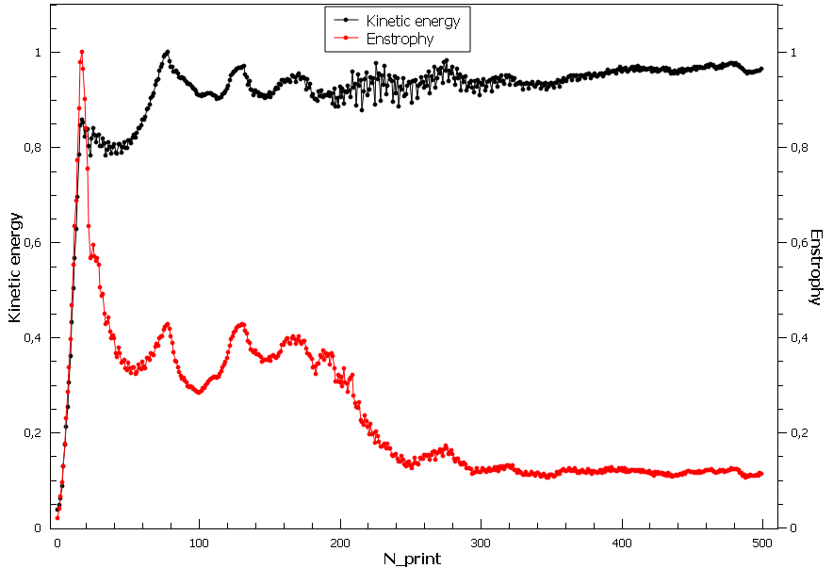

Fig.1. Graphs of kinetic energy and enstrophy on time normalized on the maximum value of these parameters.